How to use the stored procedures in SQL Server with Visual Basic 6

By: Ahmed Eissa Web: www.ahmad-nader.net.tf , Email: ahmadandnader@hotmail.com , Mobile: +44 (0)7794538129

As the title, I will show in this article how to unleash the power of Microsoft SQL Server Stored Procedures in the most popular programming language in the world: Microsoft Visual Basic 6.

Before I start, I will note that I am used in this article Microsoft Visual Basic 6 SP6 and Microsoft SQL Server 2000 Personal Edition all together on Microsoft Windows XP Professional Edition SP2, and of course my laptop.

As people know about me I am poor in writing, so I will use the pictures, which is captured during my work when I write this article.

1. Why using Stored Procedure?

People may ask you: why you using this technology while you can do the same without using it? Or in another point of view, why you use SQL stored procedure to – for example – view a report from your database while you can do the same inside your application code?

The answer is when you write your code to view data collected from more than one table on report, I know that everybody can write a code to do that in his application and it’s not such a hard job to do, but the idea from using this technology is what will come after selling your application to your customers and your customers want to make some changes on your application outputs. So better than changing the application code and regenerate a new application and give it to your customers, is just make some changes on your SQL Stored procedure and you’re done!

You should understand the PL/SQL statements and the architecture of stored procedures before going through this article.

2. Creating SQL Stored Procedure in SQL Server 2000:

To reach the goal from this article, I should show you how you can create a stored procedure in SQL Server.

First go to your Enterprise Manager and open it.

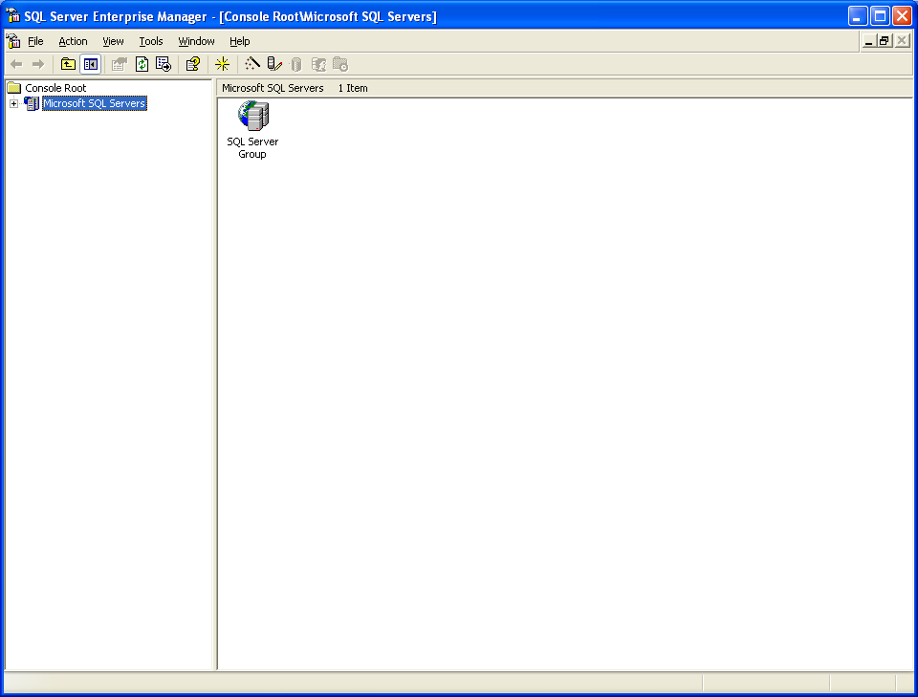

Now open “Microsoft SQL Servers” tree and click on “SQL Server Group” and then select your server name and click on “Databases” and select your database. In this article the database name is: “nv_db”.
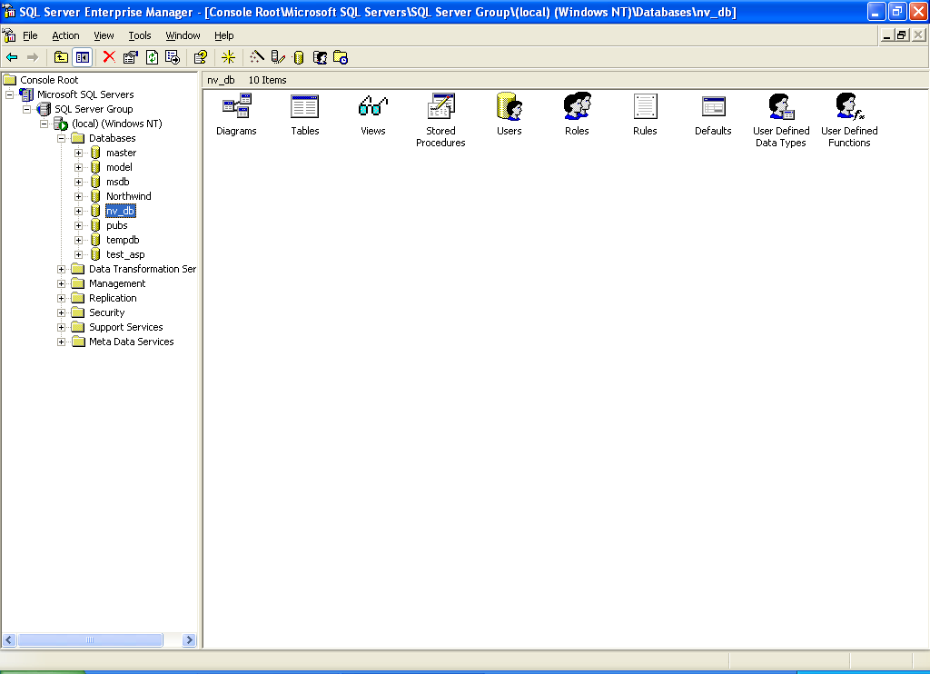

You can see now the “Stored Procedures” icon. Double-click on it and it will open all stored procedures inside your database.
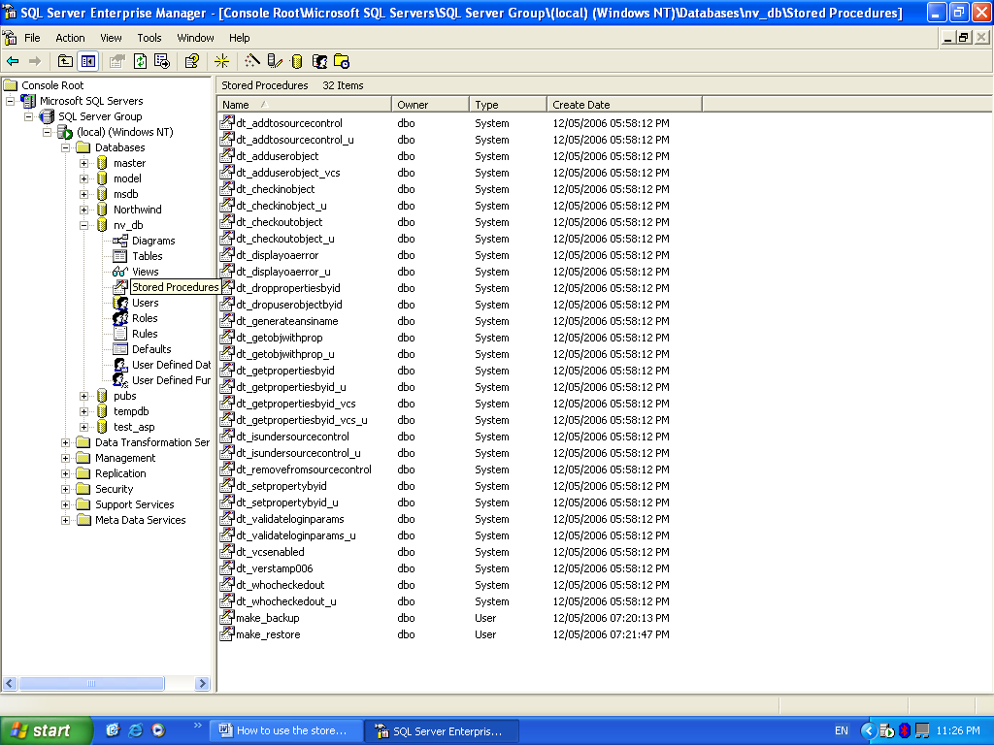

Now by clicking on icon on the toolbar you will see this window:

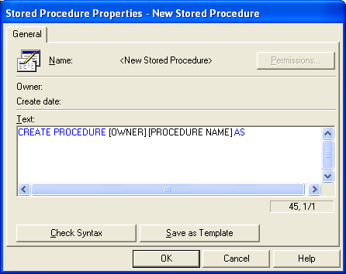
Now from here you can write a new stored procedure and save it. I know that you know how to write such like these stored procedures, or you studied about it in your college or university. Now let we write a simple two procedures that are used to backup and restore your database in and out a file.

If we take a flash look on and PL/SQL book to see what the appropriate SQL statements that can do that work, we will find two powerful statements. Those statements are: Backup Database and Restore Database. Let we use these statements to build our simple procedures. First we will create the backup procedure. In the text box in the stored procedure properties window, just place this code:

CREATE PROCEDURE dbo.make_backup AS

backup database nv_db to disk ='c:\nv_db_Backup.bak'
GO
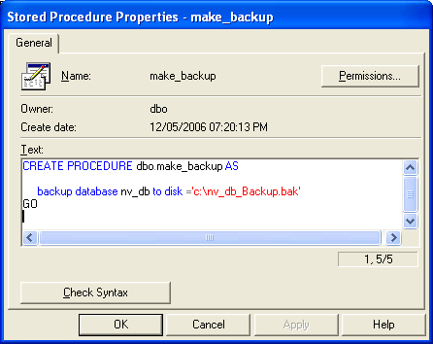
And then click on “Check Syntax” button to check your code. There is a message box appears:

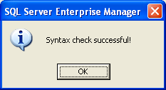

After that click on “Apply” then “OK”, then the window will close and congratulation! You get a stored procedure called “make_backup”.
Do the same with the restore procedure with this code:

CREATE PROCEDURE dbo.make_restore AS

restore database nv_db from disk ='c:\nv_db_Backup.bak'
GO
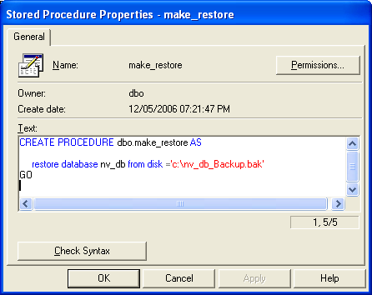
Now we have two procedures that we will connect it to our application in Visual Basic.

3. The final piece of puzzle: Using SQL stored procedures in Visual Basic:

Open a new project in Visual Basic and click on Standard EXE.
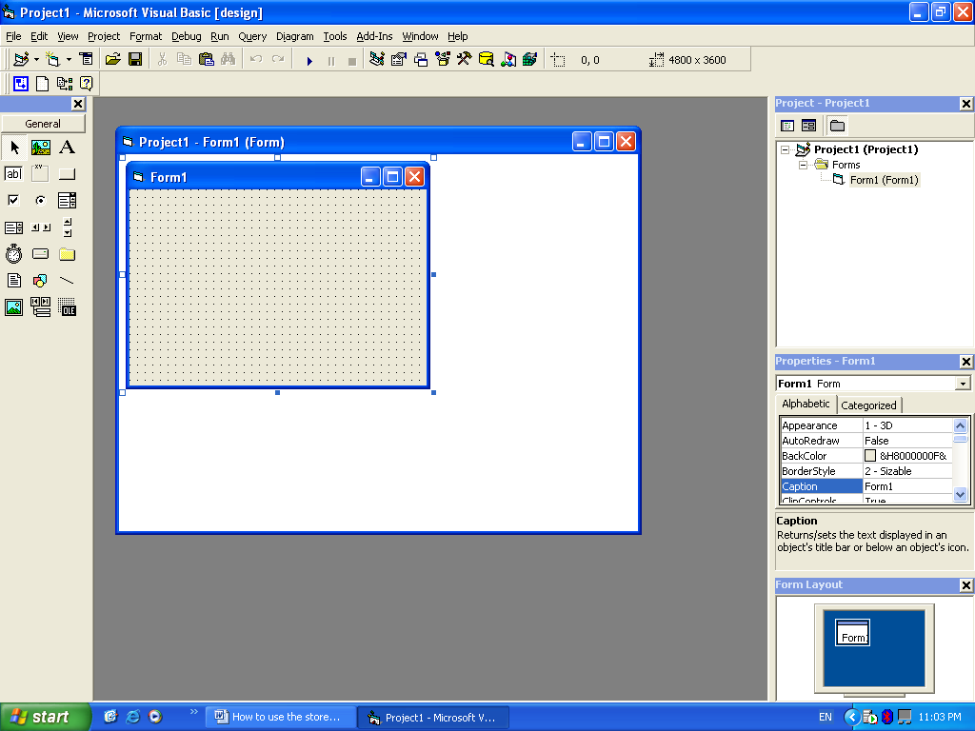

Add Data Environment to your project, and write this code to connect your application to SQL Server Database.

Private Sub DataEnvironment_Initialize()
DataEnvironment1.Connection1.ConnectionString = "Provider=SQLOLEDB.1;Integrated Security=SSPI;Persist Security Info=False;Initial Catalog=nv_db;Data Source=" & ComputerName
End Sub

Then connect your data environment as usually. The coming pictures can show you how to do it.

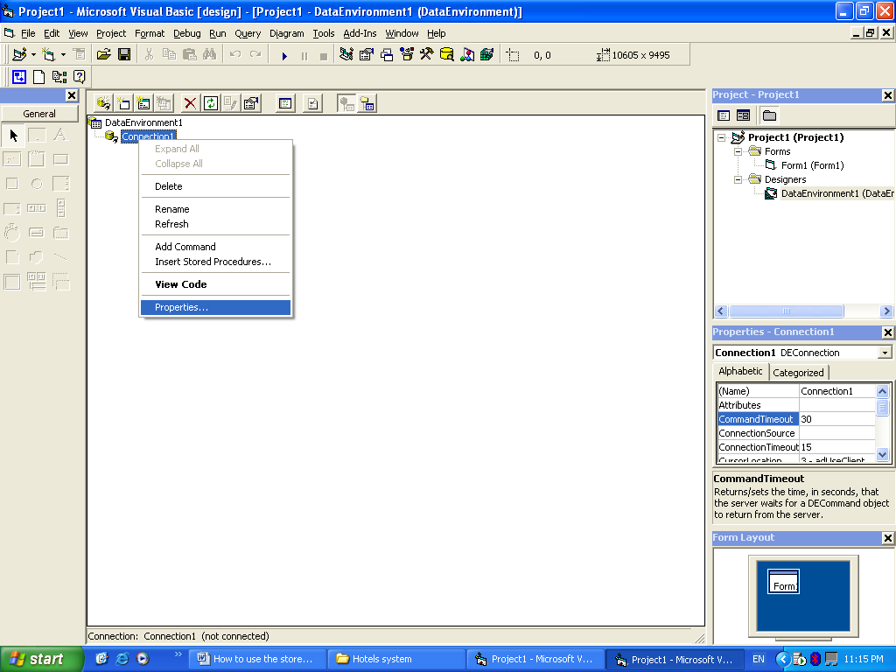

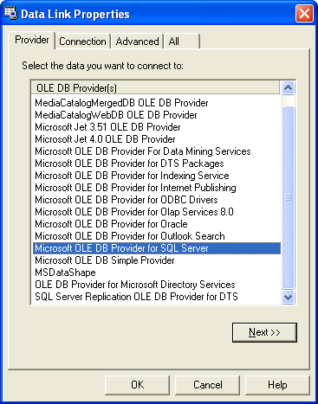

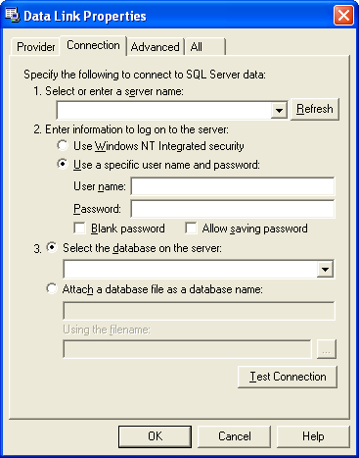

As my settings, my server name is: GATEWAY and I use Windows NT integrated security. If you have the same continue with these instructions, or place your appropriate information that meet the configuration on your PC.
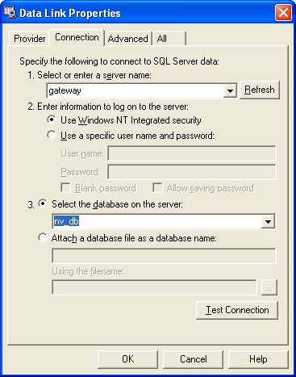

After filling the gaps, click on “Test Connection”. This message should appear:
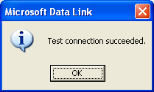
After clicking OK then OK, your application will be connected to SQL Server Database via your Data Environment.

Now right click on “Connection1” and click on “Add command”.
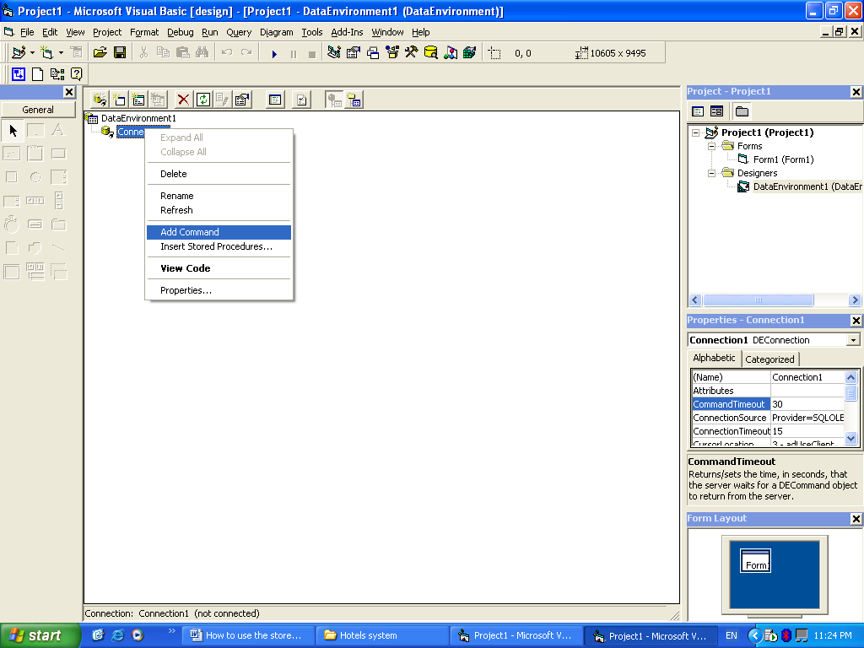

Now right click on your new command and select “Properties”.
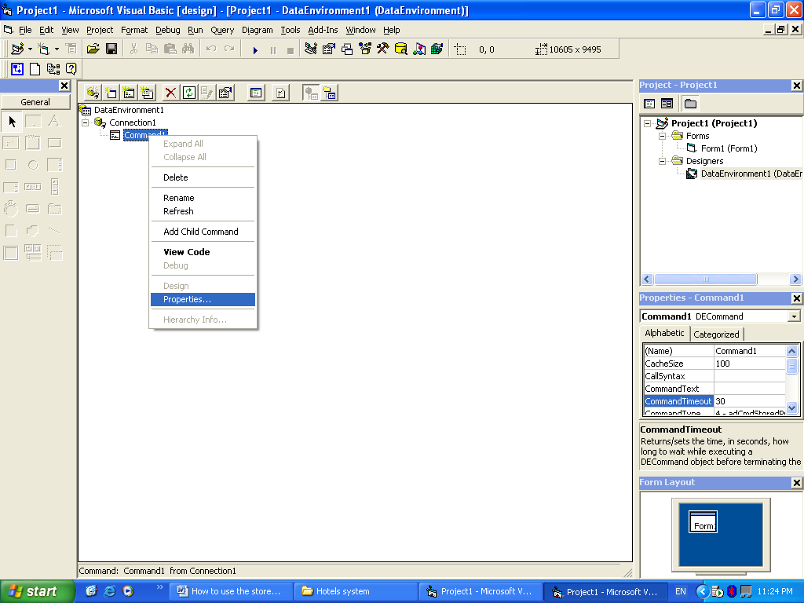

This window should appear:
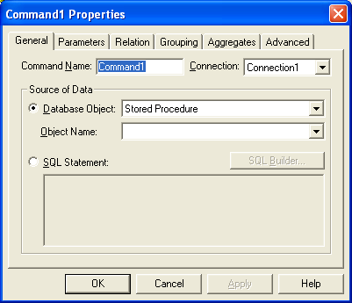

You can rename your command and give it a new name, let we name it “Do_Backup” and in the source of data select “Database Object” and leave it on “Stored Procedure”, just select from the lest your stored procedure as this picture.
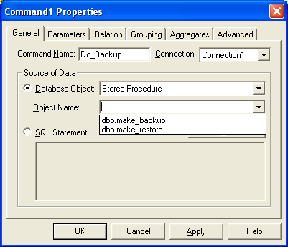

Then:
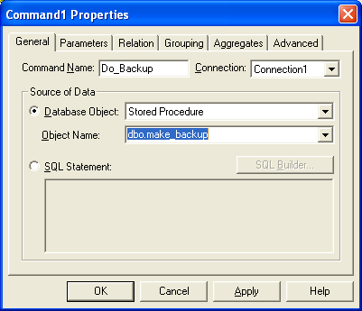

Now, click on “Apply” and then “OK” to build your first stored procedure in your application.
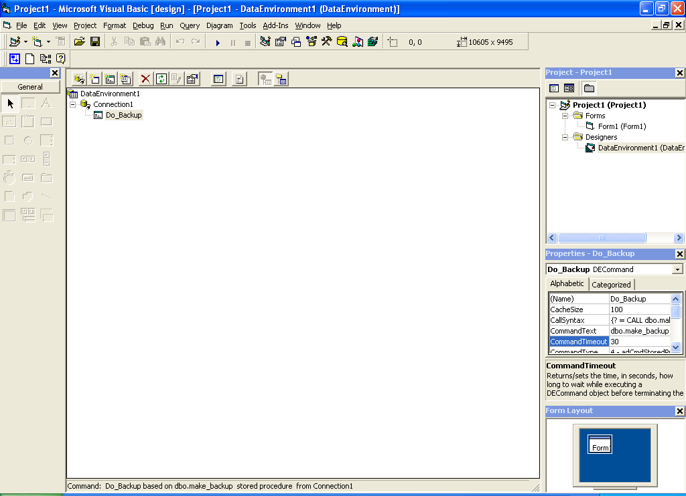

Do the same with “Do_Restore” stored procedure.
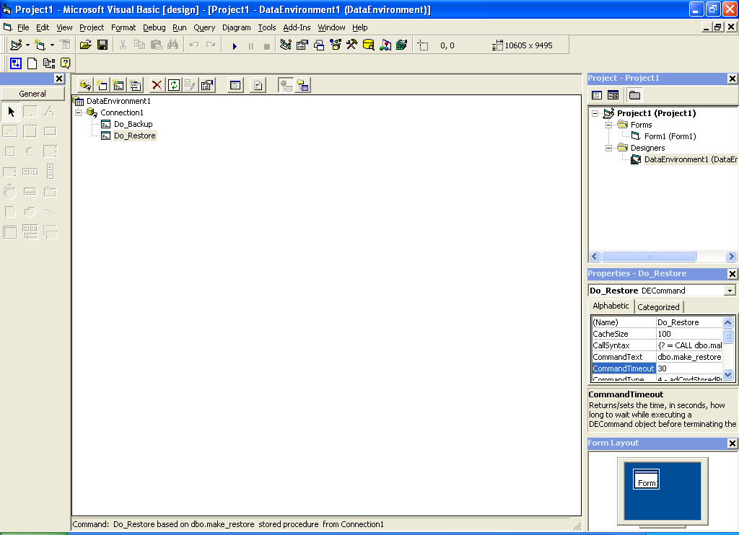

Now go back to your form. Add two commands on your form.
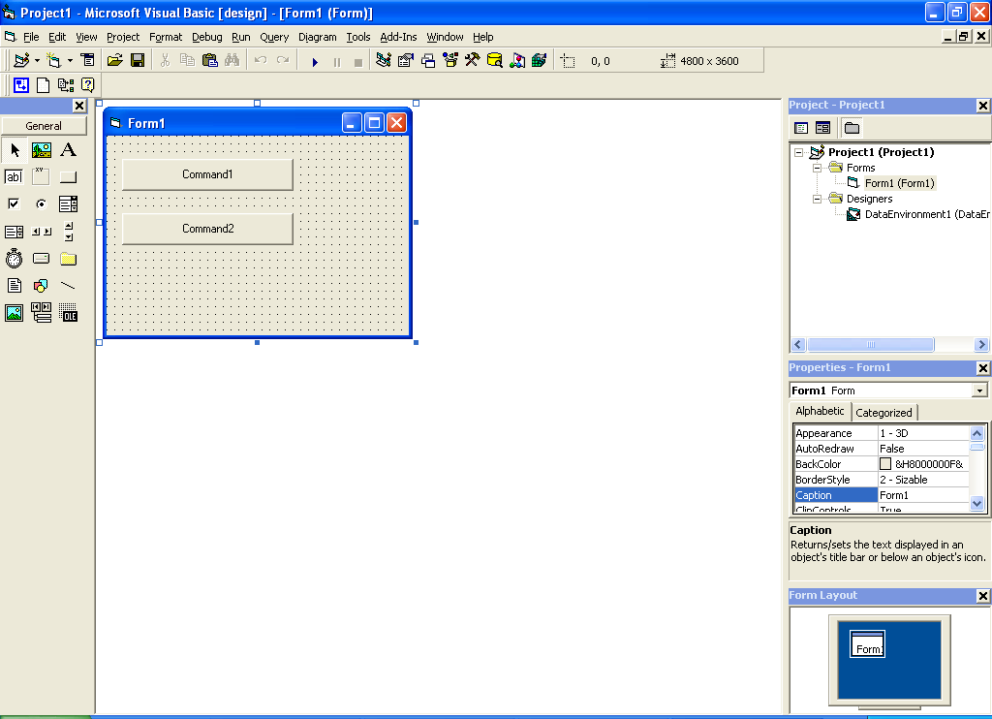

Name the first one “cmdDbBackup” and the other “cmdDbRestore”, just to make your code tidy! And caption the first button “Backup the Database” and the other “Restore the Database”. As this picture:
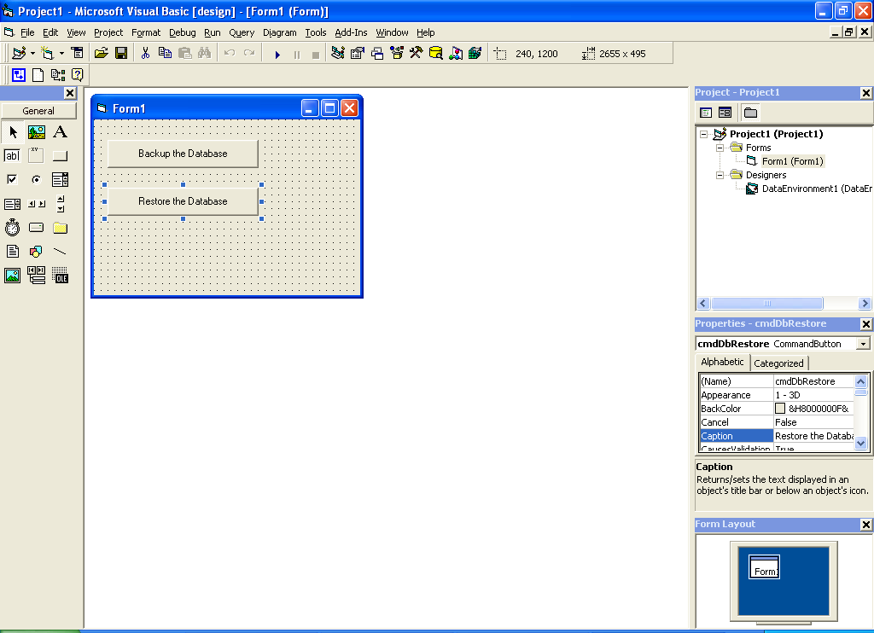

Now you are wondering what code we will use to call those stored procedures. The answer is:
In “cmdDbBackup” button place this code by double click on it:

DataEnvironment1.Do_Backup

And in “cmdDbRestore” button:

DataEnvironment1.Do_Restore

As this picture:
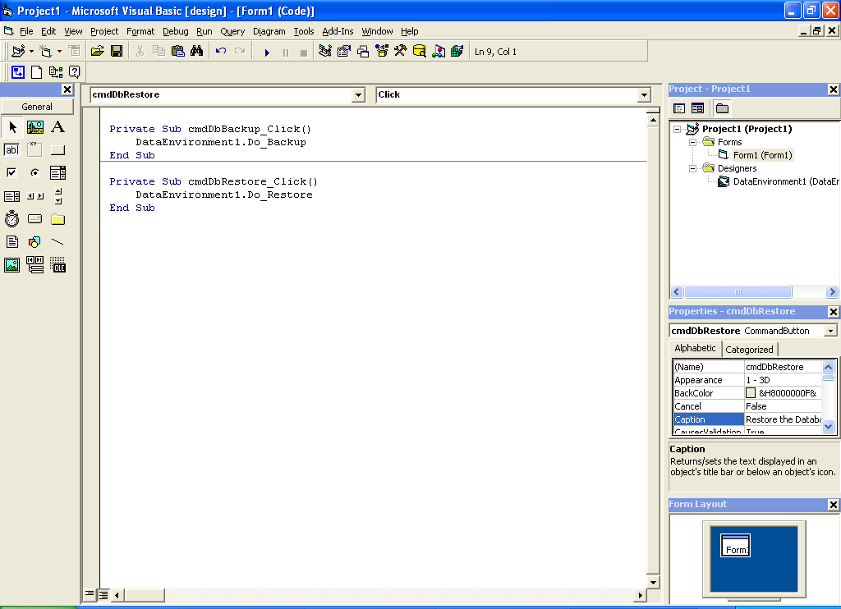

Now save the project and you will be ready to test this application, by clicking on Start button on the toolbar to execute your application. Just click on “backup the database” button to see there is a file in your Hard Drive C: called “nv_db_Backup.bak”, and this file contained a backup copy of your database with all data and relations and tables also triggers and stored procedures.

That was a useful example about how to use stored procedures in Visual Basic. I know that you can pass values to this procedures by declare appropriate parameters in the stored procedure and use it to put your variables in VB code. For example somebody want to upgrade my backup and restore procedure to let it to put the backup file in the application folder, and you can do it by declare a string variable to use it for this propose. And I know that you can write another procedure better than me, but it was a small example to use it in my article.

The code is attached with this article, but the database is not because it does belong to my project and it’s very large to upload on Planet Source Code.

Thank you,

EOF.

